Pil R So, Amy Barrera, Raven Malone, Joaquin Vasquez, Ashley Suriel

Objective

Mass Email to a company getting their LinkedIn accounts spreading miss information to make the stock of a company go down.

Cat PHISh

Whaling on the company

First you need to download the zphiser on github

Git clone <https://github.com/htr-tech/zphisher.git>

Ls

Cd zphisher

Sudo ./zphisher

Press 14 to LinkedIn so we can start spear phishing so we can get a whale.

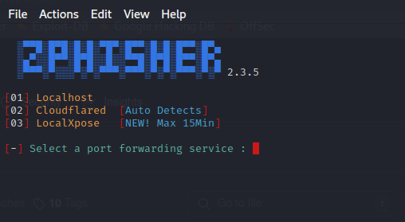

Port Forwarding service: 2 to use cloud flared

No custom port

You now have links so now we have to use another tool, while leaving this open

Now we have to use the Social Engineering Toolkit (set)

Press 1 for Social- Engineering Attack

Press 5 for Mass Mailer Attack

Press 1 for single email attack

Press 2 for One-time Use email

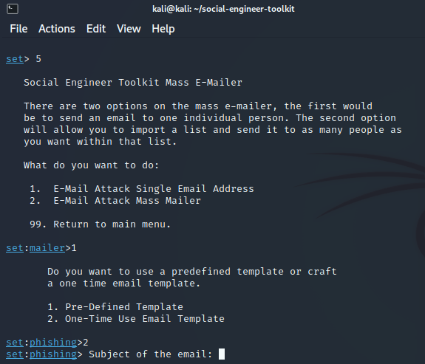

Subject: Urgent: Action Required on Your LinkedIn Account

Enter the body of the message:

Dear PickeRick,

We have detected unusual activity on your LinkedIn account that requires immediate attention to secure your profile and data. To ensure the security of your account, please click the link below to verify your identity and review recent login attempts:

[Insert Link] using ZPHISHER

Your prompt action is crucial in maintaining the integrity of your LinkedIn account. If you have any concerns or need further assistance, please contact our support team immediately.

Thank you for your cooperation.

Best regards,

The LinkedIn Team

Send Email to: [pickrickceo@yahoo.com](mailto:pickrickceo@yahoo.com)

Press 1 for your own gmail account with the password.

It will look something like this

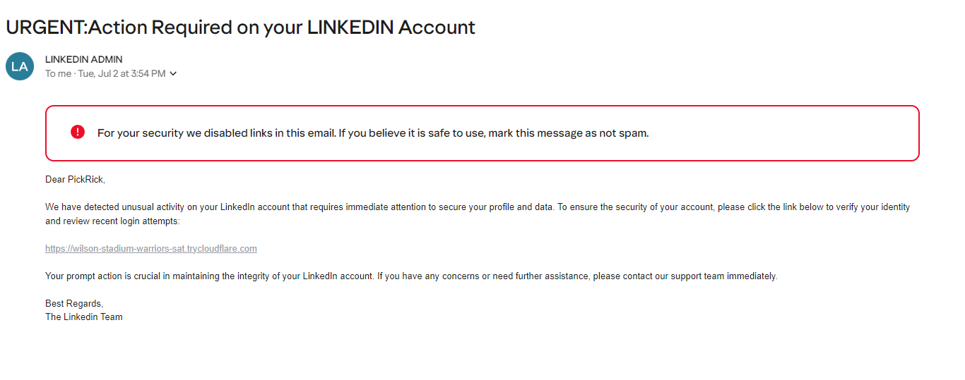

It will look something like this after which

You click on the link it would bring you to the sign in for LinkedIn.

When the target whale puts in the username and password.

The ZPhisher will pick it up and give it to you like this

Now you can mess with the whale in his LinkedIn account.